**Correlation coefficients** measure the strength of association between two variables. The most common correlation coefficient, called the **Pearson product-moment correlation coefficient**, measures the strength of the *linear association* between variables.

The sign and the [absolute value](https://www.stattrek.com/Help/Glossary.aspx?Target=Absolute_value) of a Pearson correlation coefficient describe the direction and the magnitude of the relationship between two variables.

* The value of a correlation coefficient ranges between -1 and 1.
* The greater the absolute value of a correlation coefficient, the stronger the *linear* relationship.
* The strongest linear relationship is indicated by a correlation coefficient of -1 or 1.
* The weakest linear relationship is indicated by a correlation coefficient equal to 0.
* A positive correlation means that if one variable gets bigger, the other variable tends to get bigger.
* A negative correlation means that if one variable gets bigger, the other variable tends to get smaller.

Keep in mind that the Pearson correlation coefficient only measures linear relationships. Therefore, a correlation of 0 does not mean zero relationship between two variables; rather, it means zero *linear* relationship. (It is possible for two variables to have zero linear relationship and a strong curvilinear relationship at the same time.)

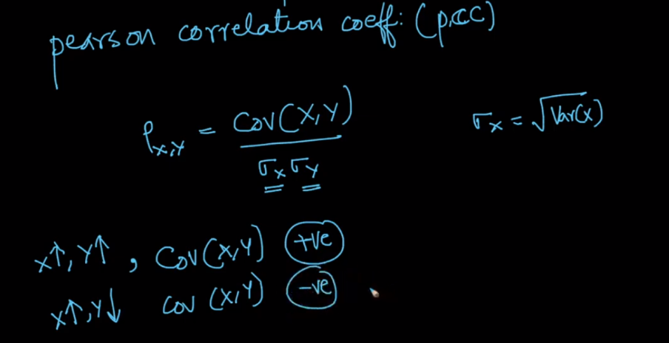

Below figure shows the PCC value and their relationship for 5 different kind of relationships:

1. If all the points lies on the straight line, then it’s PCC value will exactly +1 or -1, which shows strongest linear relationships among two variables.
2. If all the points do not lie on the straight line, but still they follow some trend (increase with increasing, decreases with decreasing), then the PCC value will be either -1 < PCC < 0 or 0<PCC<+1, which shows comparatively weak relationships.
3. If points don’t lie on st. line and even don’t follow any trend then the PCC will be 0, that means there is no linear relationship.

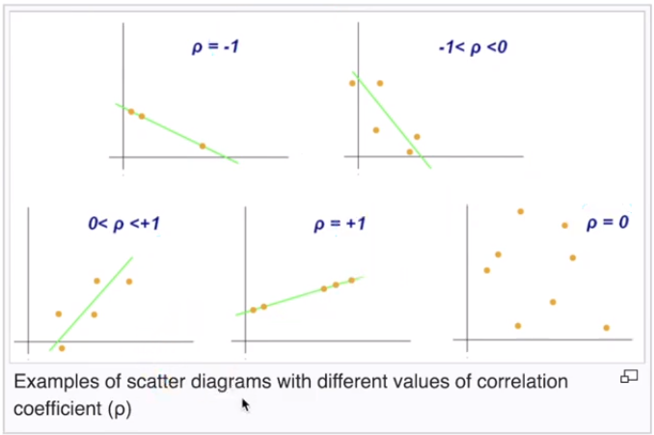

Note: PCC doesn’t care about how much theta angle is there from x-axis, it’s just consider the trend and whether points fall on st. line or not.

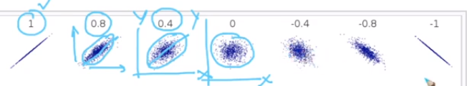

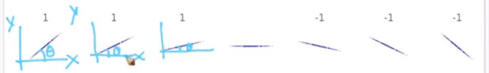

Below figure shows, variables with 0 linear relationship.

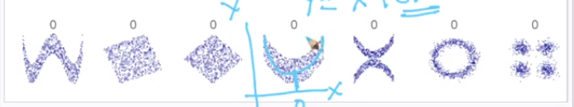

Monotonically relationship:

Monotonic means either increasing or decreasing, therefore:

* For monotonically increasing if x2 > x1 then must y2 > y1
* For monotonically decreasing if x2 < x1 then must y2 < y1

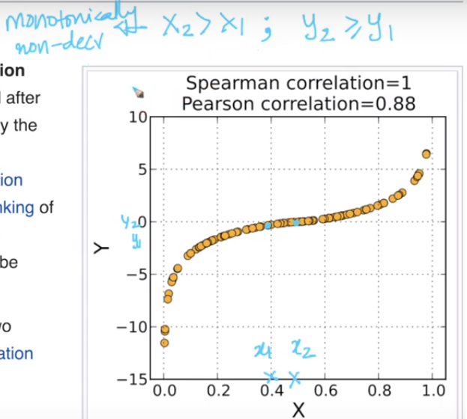

Some Comments:

